Majorca Daily Bulletin
£0.50
YOUR DAILY FAVOURITE NEWSPAPER
TYPHOON CRUSHES PHILIPPINES
Typhoon Haiyan, known as Typhoon Yolanda in the Philippines, was an exceptionally powerful tropical cyclone that devastated portions of Southeast Asia, particularly the Philippines, on November 11th 2013

Facts
On the 11th November 2013, Typhoon Yolanda struck the Philippines with deadly winds causing devastating destruction. More than 1,000 islands and 11,000 people were affected. The death toll from Typhoon in Haiyan has risen above 5,000.
Officials in the Philippines communicated, two weeks after the devastating storm hit the country. The countries National Disaster Agency said that 5,209 people were known to have lost their lives with many more still missing.

Level of Devastation
Houses, hospitals, businesses etc., were destroyed and children were orphaned. The horrifying chaos left Haiyan flattened, this is judged to have been the deadliest typhoon ever.
Humanitarian Help
Finally after the Typhoon passed, the residents of the Philippines’ had time to try and find their relatives but many had died from the disastrous attack from the sea. Later on, the President deployed doctors to help the remaining people.
As to date, there is still an enigma regarding how many people are still missing. How many people have still not been found? Will we ever really know?

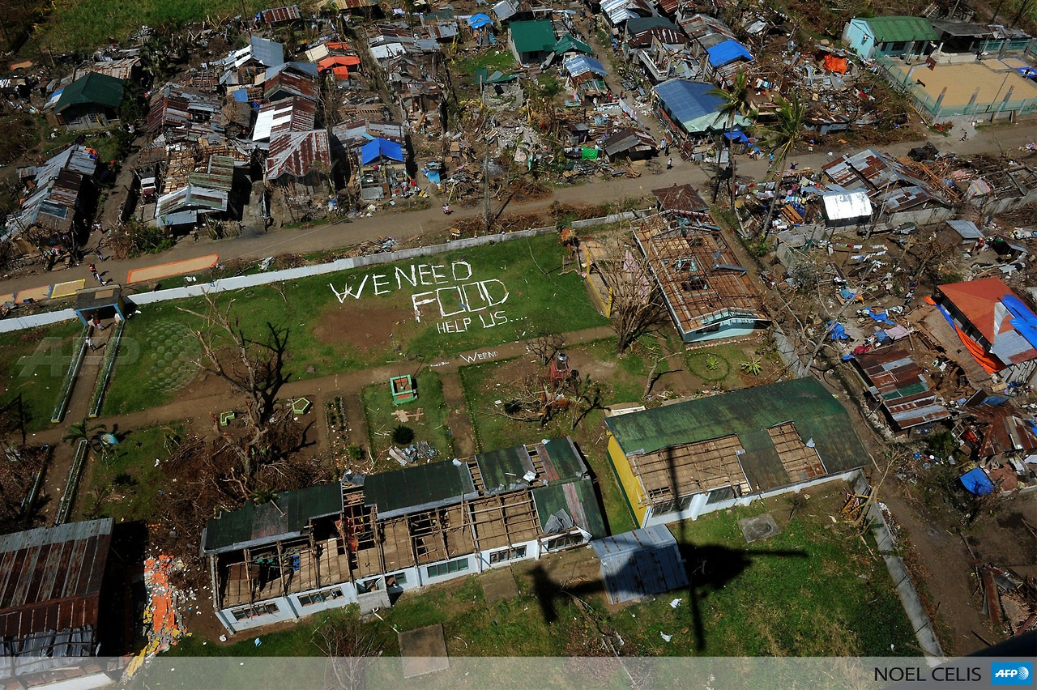
The only difference between a hurricane, a cyclone and a typhoon is the location where the storm occurs

Typhoon Haiyan devastation
Did you know?
Hurricanes, cyclones, and typhoons are all the same weather phenomenon; we just use different names for these storms in different places. In the Atlantic and Northeast Pacific, the term “hurricane” is used. The same type of disturbance in the Northwest Pacific is called a “typhoon” and “cyclones” occur in the South Pacific and Indian Ocean. The ingredients for these storms include a pre-existing weather disturbance, warm tropical oceans, moisture, and relatively light winds. If the right conditions persist long enough, they can combine to produce the violent winds, incredible waves, torrential rains and floods we associate with this phenomenon.

In the Atlantic, hurricane season officially runs from June 1st to November 30th. However, while 97% of tropical activity occurs during this time period, there is nothing magical in these dates, and hurricanes have occurred outside of these six months.
By Louis Clay

