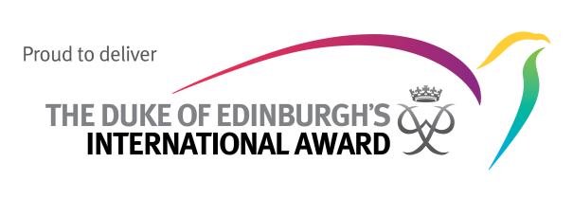
Bellver International College is proud to deliver The Duke of Edinburgh’s International Award

The Award
The Duke of Edinburgh’s International Award is the world’s leading youth achievement award, bringing together practical experiences and life skills to equip young people for life. Since it was founded in 1956 by His Royal Highness The Duke of Edinburgh (husband to Queen Elizabeth II of the United Kingdom), over eight million young people have participated in the Award in over 140 countries and territories. Schools, colleges, universities, employers, social clubs, youth organisations such as the Scouts, Girl Scouts and Girl Guides, young offenders’ institutions, religious organisations, sports clubs and more all run the Award. Bellver International College is proud to offer the Award to young people aged 14 to 18. Our Award Leader is Mr Garcia.

What is involved?
The Award is voluntary, non-competitive, enjoyable and balanced, and requires effort over time. There are three levels to the Award: Bronze, Silver and Gold. Young people design their own Award programme, set their own goals and record their own progress. They choose a Service, Physical Recreation, Skills activity, go on an Adventurous Journey and, to achieve a Gold Award, take part in a residential project. The only person they compete against is themselves, by challenging their own beliefs about what they can achieve.

Further information
More information on The Duke of Edinburgh’s International Award can be found at www.intaward.org. You can also connect with the Award on Facebook, Twitter and on YouTube.

For information about the Award in Bellver International College please contact:
Alex Garcia, Award Leader.
Email: garciaa@bellvercollege.com
Phone: 971 401 679

